**Practical no.-**22

**Title:** Develop a program to implement Sensor.

**Roll No.:**15 **Batch-** A **Date of Performance:** 04/03/2024

**activity_main.xml**

<?xml version="1.0" encoding="utf-8"?>

<AbsoluteLayout xmlns:android="http://schemas.android.com/apk/res/android"

xmlns:app="http://schemas.android.com/apk/res-auto"

xmlns:tools="http://schemas.android.com/tools"

android:layout_width="match_parent"

android:layout_height="match_parent"

tools:context=".MainActivity">

<TextView

android:id="@+id/tv"

android:layout_width="wrap_content"

android:layout_height="wrap_content"

android:layout_x="59dp"

android:layout_y="278dp"

android:text="Light Sensor Intensity"

android:textSize="25dp" />

</AbsoluteLayout>

**MainActivity.java**

package com.example.pract_22sensors;

import androidx.appcompat.app.AppCompatActivity;

import android.os.Bundle;

import android.hardware.*;

import android.widget.TextView;

public class MainActivity extends AppCompatActivity implements SensorEventListener{

TextView tv;

SensorManager sm;

Sensor light;

@Override

protected void onCreate(Bundle savedInstanceState) {

super.onCreate(savedInstanceState);

setContentView(R.layout.activity_main);

tv=(TextView) findViewById(R.id.tv);

sm=(SensorManager)

getSystemService(SENSOR_SERVICE); light=sm.getDefaultSensor(Sensor.TYPE_LIGHT); sm.registerListener((SensorEventListener) this,light,SensorManager.SENSOR_DELAY_NORMAL);

}

public void onSensorChanged(SensorEvent event) { if(event.sensor.getType()==Sensor.TYPE_LIGHT)

{

tv.setText("Light Intensity="+event.values[0]);

}

}

@Override

public void onAccuracyChanged(Sensor sensor, int accuracy) { }

}

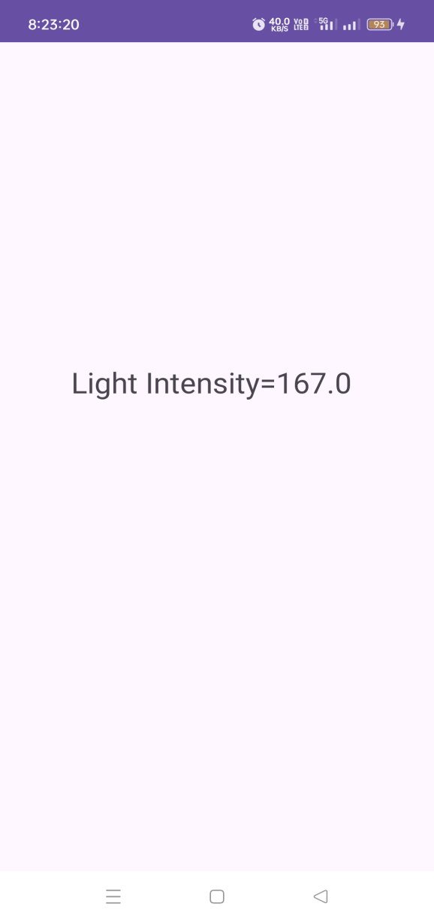

**Outputs-**



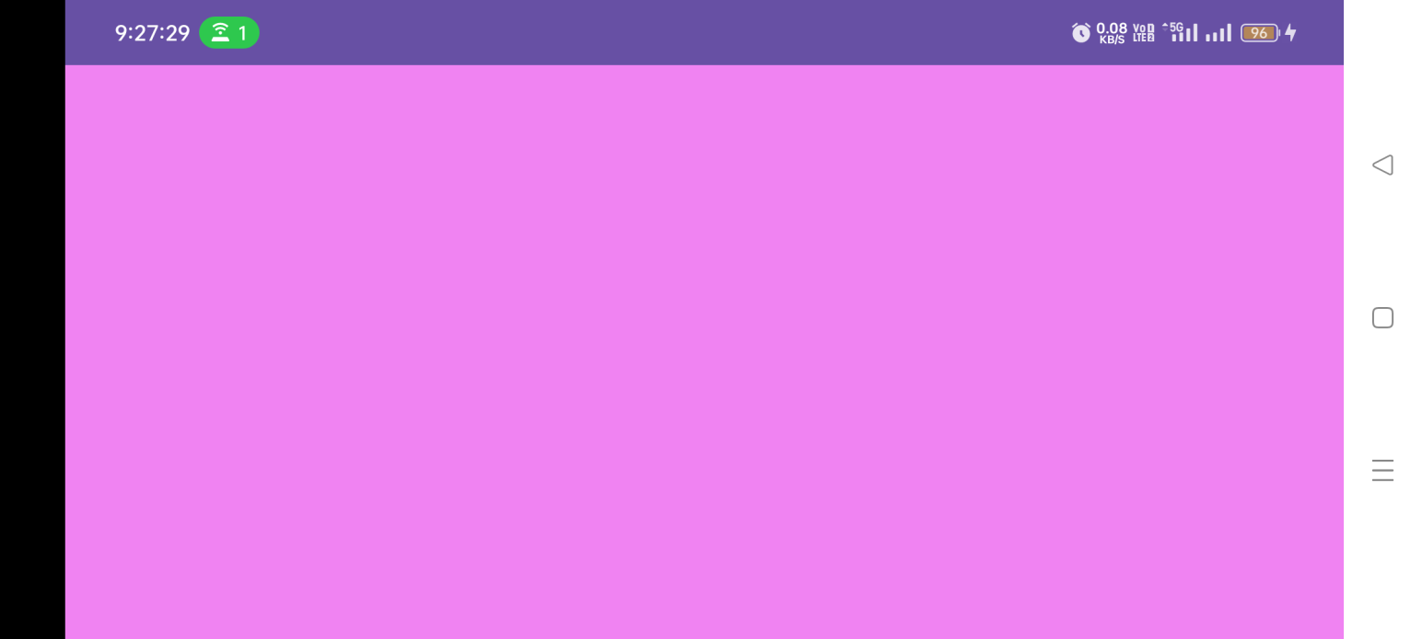

1. **activity_main.xml**

<?xml version="1.0" encoding="utf-8"?>

<LinearLayout xmlns:android="http://schemas.android.com/apk/res/android"

xmlns:app="http://schemas.android.com/apk/res-auto"

xmlns:tools="http://schemas.android.com/tools"

android:layout_width="match_parent"

android:layout_height="match_parent"

tools:context=".MainActivity">

<ListView

android:id="@+id/lv"

android:layout_width="match_parent"

android:layout_height="match_parent"

/>

</LinearLayout>

**MainActivity.java**

package com.example.pract_222listsensors;

import androidx.appcompat.app.AppCompatActivity;

import android.annotation.SuppressLint;

import android.content.Context;

import android.hardware.Sensor;

import android.hardware.SensorManager;

import android.os.Bundle;

import android.widget.ArrayAdapter;

import android.widget.ListView;

import java.util.List;

public class MainActivity extends AppCompatActivity {

ListView lv;

SensorManager sm;

List <Sensor> sensor;

@SuppressLint("MissingInflatedId")

@Override

protected void onCreate(Bundle savedInstanceState) {

super.onCreate(savedInstanceState);

setContentView(R.layout.activity_main);

sm=(SensorManager) getSystemService(Context.SENSOR_SERVICE);

lv=(ListView) findViewById(R.id.lv);

sensor=sm.getSensorList(Sensor.TYPE_ALL);

lv.setAdapter(new ArrayAdapter<Sensor>(this, android.R.layout.simple_list_item_1,sensor));

}

}

